Digital Image Processing – Homework 1

Jacob Taylor Cassady

September 3, 2019

# Reduce the representation of the image lenna.jpg from 8 bits per pixel using the following substitution table:

|  |  |
| --- | --- |
| F | G |
| 0-15 | 7 |
| 16-31 | 23 |
| 32-47 | 39 |
| … | … |
| 240-256 | 247 |

## 

## Apply imshow to image g

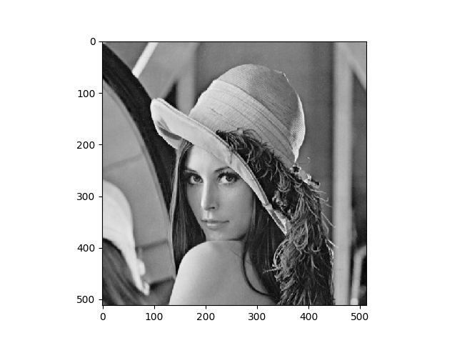

## Compute the average error between f and g.

Mean Squared Error between intital image and quantized image = 21.998451232910156

## Source Code

import numpy as np

import matplotlib.pyplot as plt

import imageio

import os

import sys

def mse(array1, array2, axis=None):

return ((array1 - array2)**2).mean(axis=axis)

class Quantizer():

@staticmethod

def quantize_image(image_array):

quantized_image = np.copy(image_array)

for row_index, row in enumerate(image_array):

for column_index, pixel in enumerate(row):

if pixel >= 0 and pixel < 16:

quantized_image[row_index, column_index] = 7

elif pixel >= 16 and pixel < 32:

quantized_image[row_index, column_index] = 23

elif pixel >= 32 and pixel < 48:

quantized_image[row_index, column_index] = 39

elif pixel >= 48 and pixel < 64:

quantized_image[row_index, column_index] = 55

elif pixel >= 64 and pixel < 80:

quantized_image[row_index, column_index] = 71

elif pixel >= 80 and pixel < 96:

quantized_image[row_index, column_index] = 87

elif pixel >= 96 and pixel < 112:

quantized_image[row_index, column_index] = 103

elif pixel >= 112 and pixel < 128:

quantized_image[row_index, column_index] = 119

elif pixel >= 128 and pixel < 144:

quantized_image[row_index, column_index] = 135

elif pixel >= 144 and pixel < 160:

quantized_image[row_index, column_index] = 151

elif pixel >= 160 and pixel < 176:

quantized_image[row_index, column_index] = 167

elif pixel >= 176 and pixel < 192:

quantized_image[row_index, column_index] = 183

elif pixel >= 192 and pixel < 208:

quantized_image[row_index, column_index] = 199

elif pixel >= 208 and pixel < 224:

quantized_image[row_index, column_index] = 215

elif pixel >= 224 and pixel < 240:

quantized_image[row_index, column_index] = 231

elif pixel >= 240 and pixel < 256:

quantized_image[row_index, column_index] = 247

return quantized_image

if __name__ == "__main__":

args = sys.argv

if(len(args) != 2):

print("Command Line Arguments should follow the format:")

print("python Quantizer.py [relative_image_path]")

else:

image_path = sys.argv[1]

# Read image:

image = imageio.imread(image_path)

print("Initial image: ")

print(image, image.shape)

# Display image:

plt.imshow(image, cmap='gray')

plt.show()

# Quantize image:

quantized_image = Quantizer.quantize_image(image)

print("Quantized image: ")

print(quantized_image, quantized_image.shape)

# Display quantized image:

plt.imshow(image, cmap='gray')

plt.show()

# Calculate Mean Squared Error

print("Mean Squared Error between intital image and quantized image = {}".format(mse(image, quantized_image)))

# 2.11

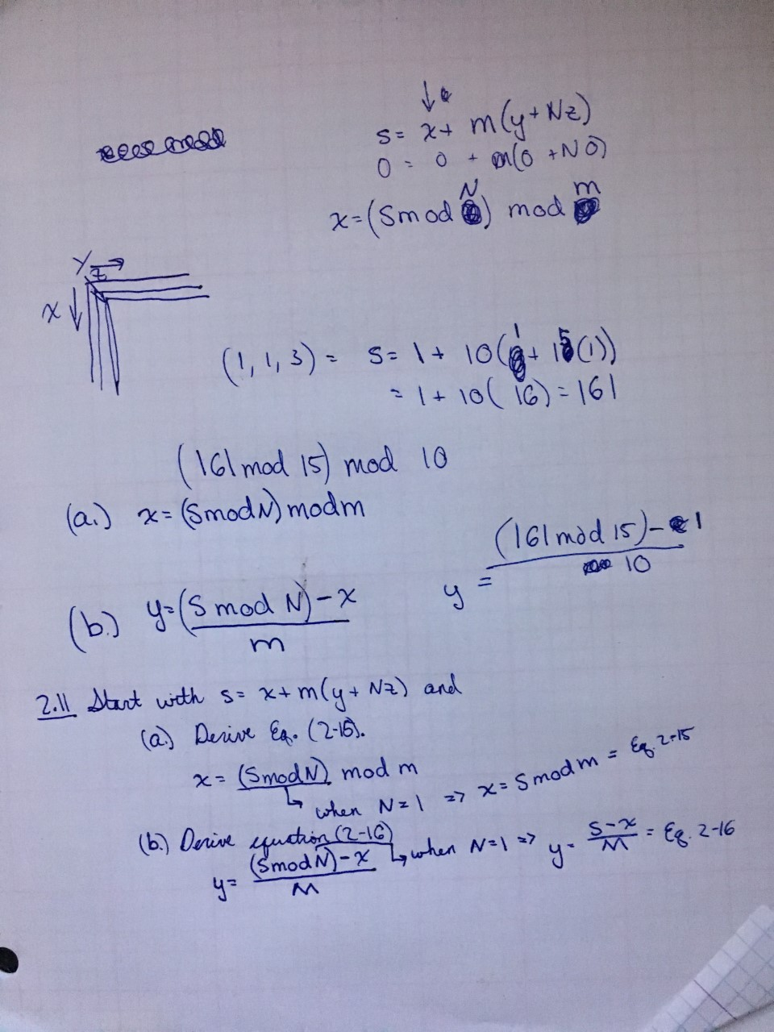

# 2.14

## a. Subsets S1 and S2 are not 4-adjacent.

## b. Subsets S1 and S2 are 8-adjacent.

## c. Subsets S1 and S2 are not m-adjacent

# 2.15

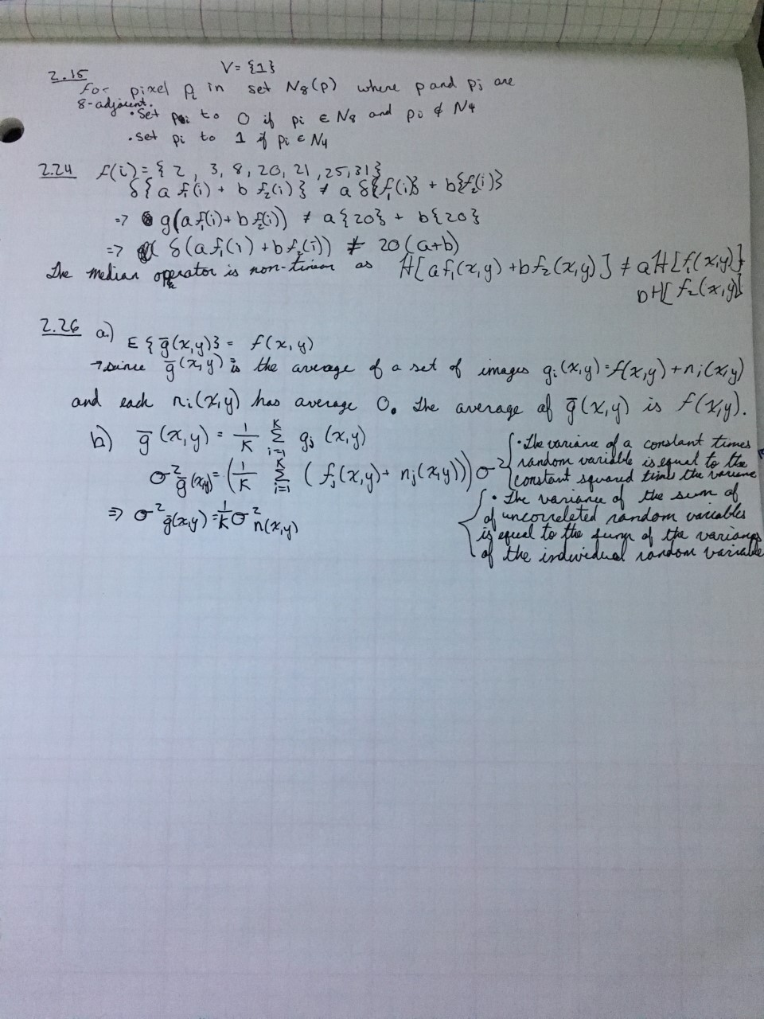

# 2.24



# 2.26

